**Network Task**

**Task Description:**

**1.Get me the IP address of a particular domain (guvi.in). How do I find my CPU/memory usage of my server? Test the connectivity between 2 nodes?**

**Step1 :** IP address of a particular domain (guvi.in)

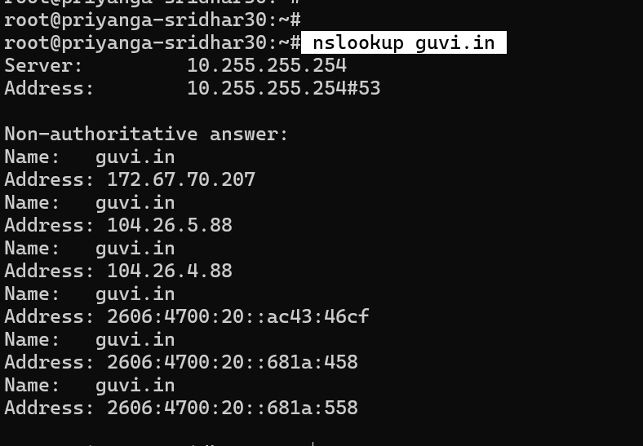

**Step 2:** CPU/memory usage of server

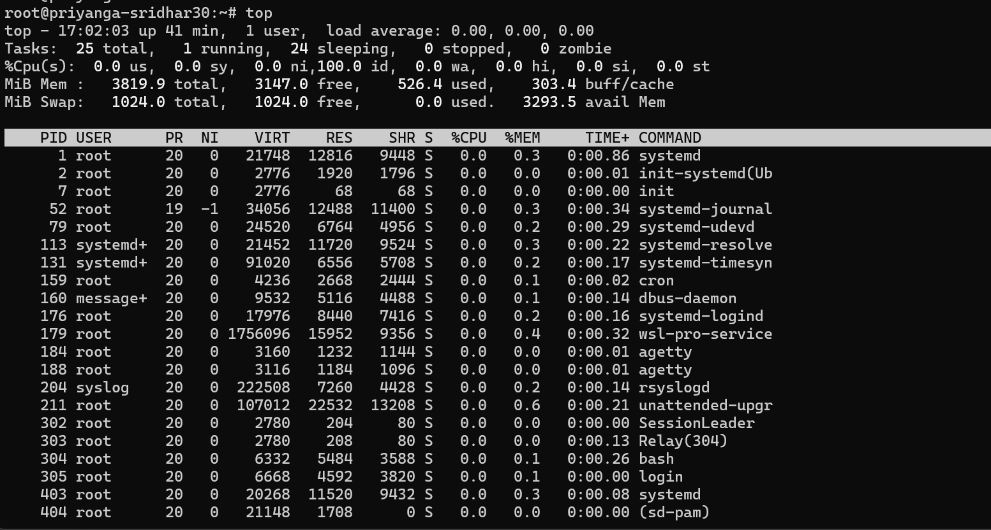

**Step 3:** Test the connectivity between 2 nodes

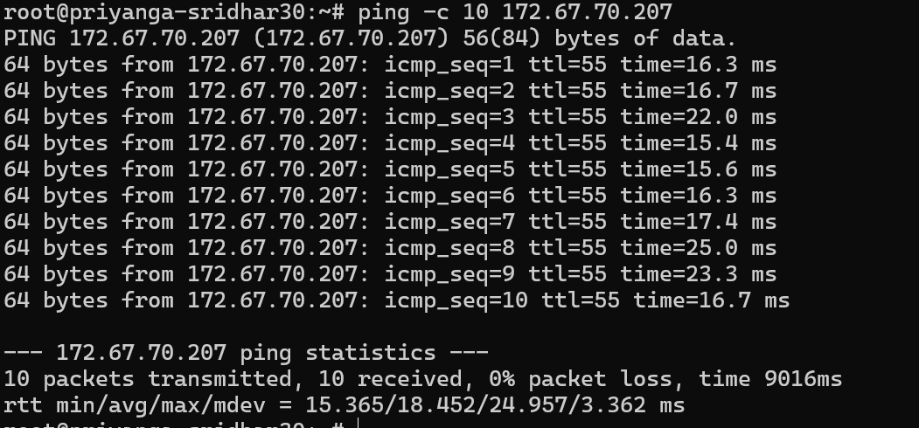

**2.I have deployed an application in guvi.com:9000, and logs show my app is running, but I’m unable to view the page. Check whether my port is open or not?**

Check if Port 9000 is Open for guvi.com:9000:

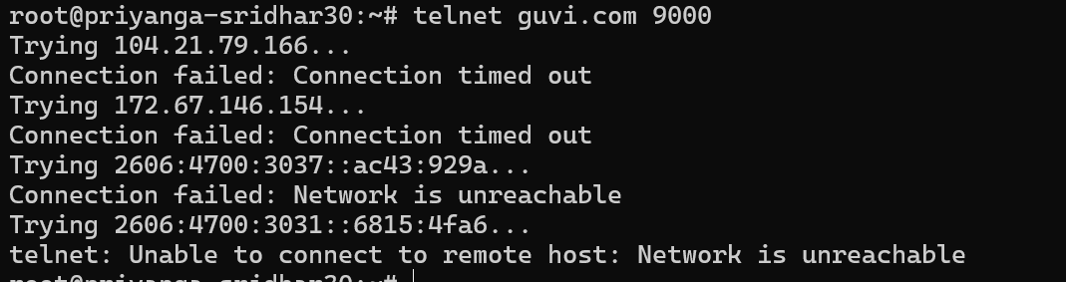

The errors suggest that port guvi.in 9000 is closed ,blocked by firewall.